gw_elevation_mtgnn — Program Flow Documentation
Generated: February 2026

Flow Diagram
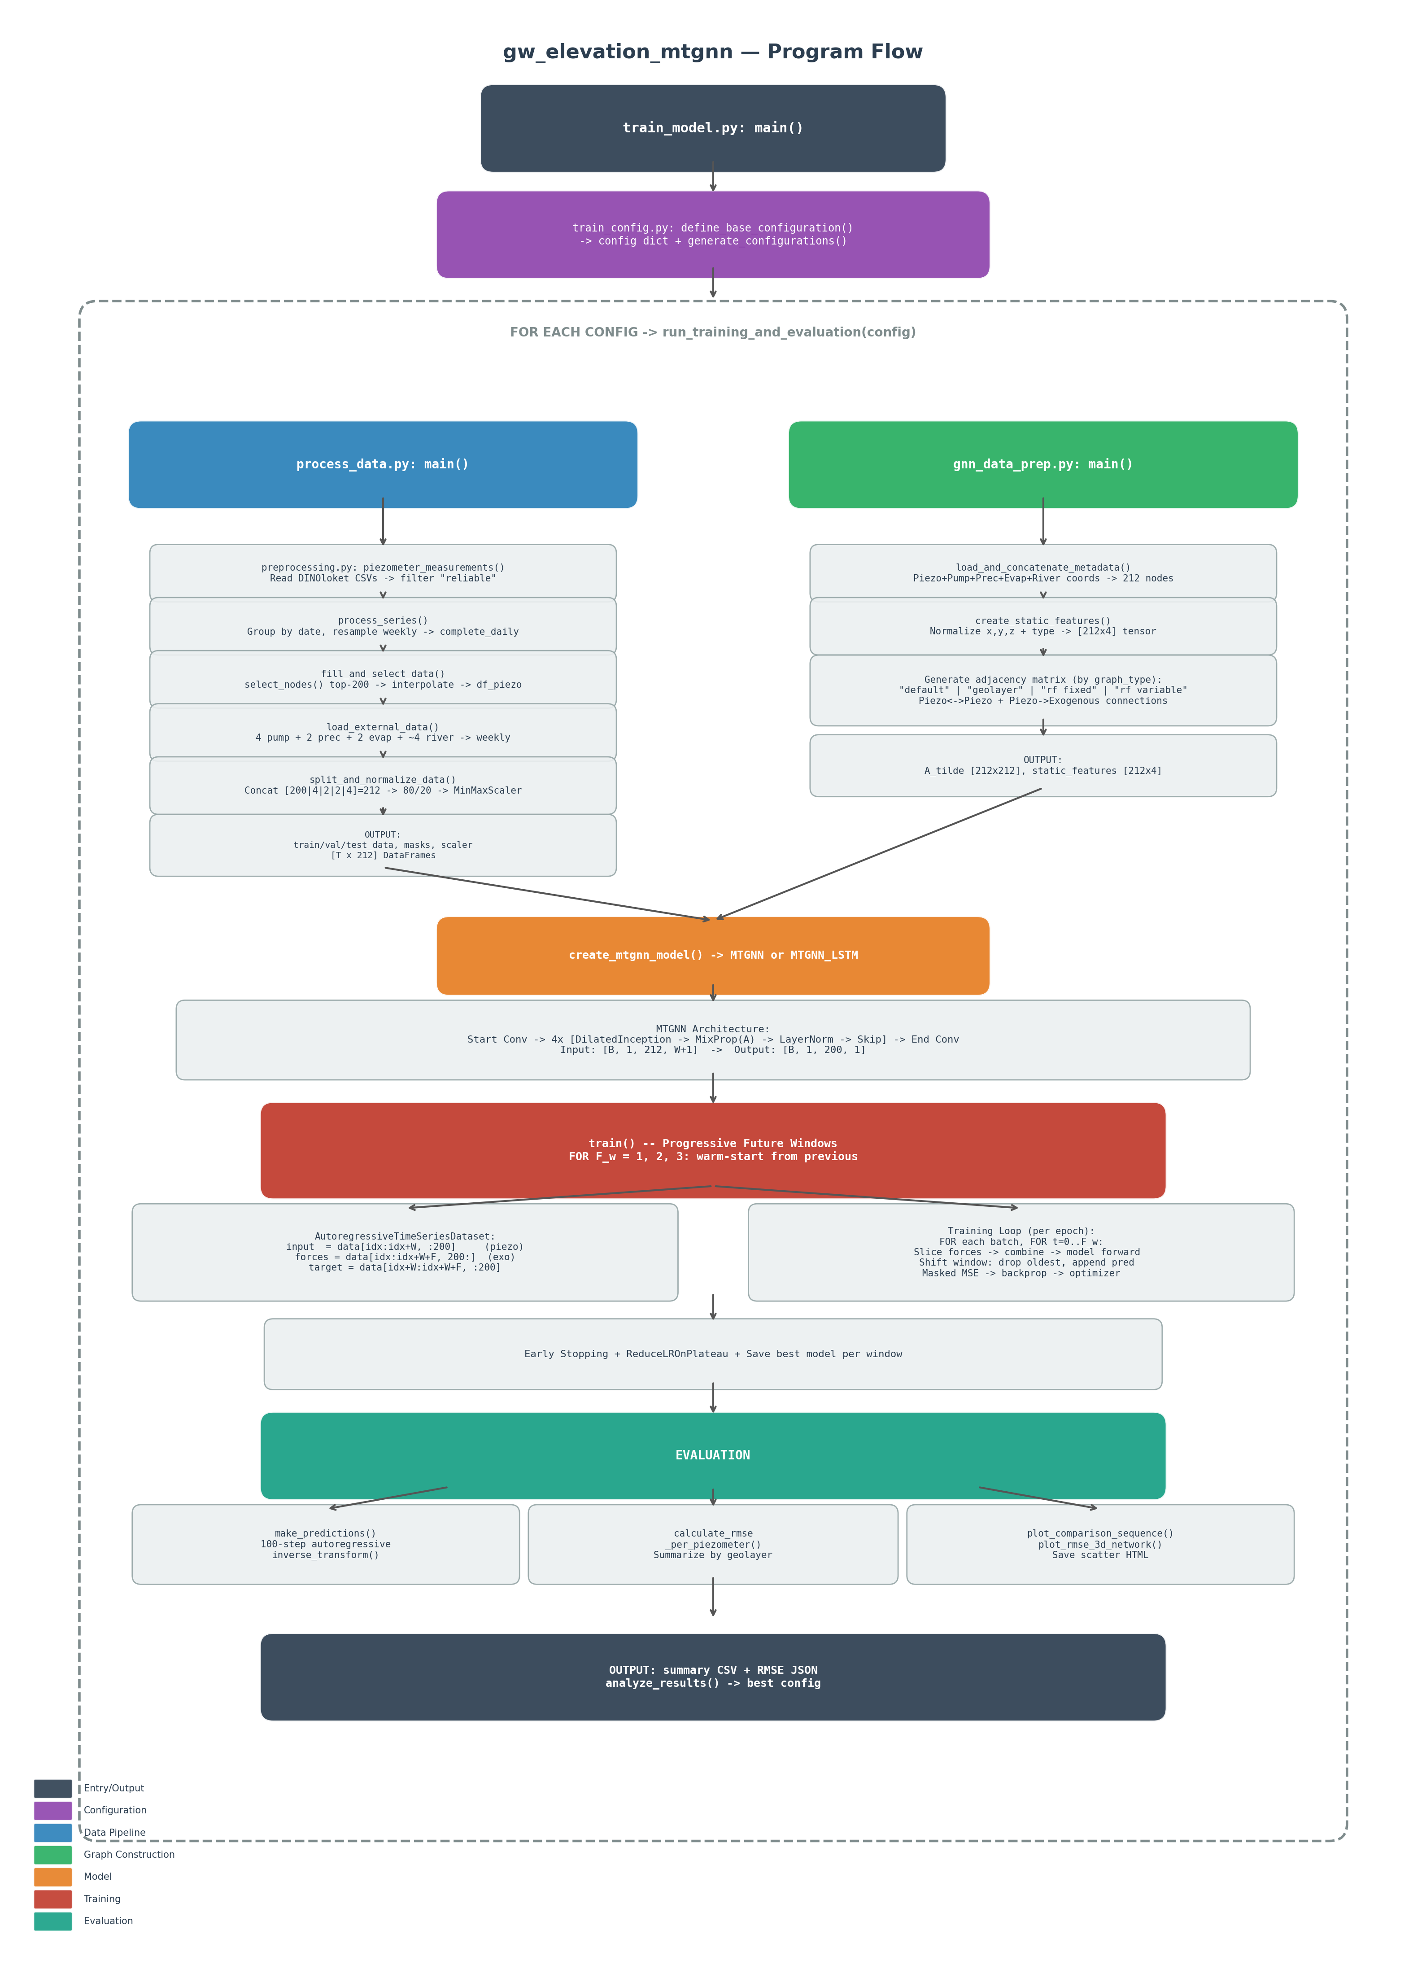

Detailed Program Flow

1. Entry Point — train_model.py: main()
The program starts in train_model.py main(). It loads the base configuration from train_config.py: define_base_configuration(), generates configuration variants via generate_configurations(), and iterates over each config calling run_training_and_evaluation(config).

2. Data Pipeline — process_data.py: main()
Called first inside run_training_and_evaluation(). Responsible for loading, cleaning, and preparing all time series data.
2a. Load Piezometer Data: preprocessing.py: piezometer_measurements() reads DINOloket CSV files per well. Filters to "reliable" measurements only (BIJZONDERHEID column).
2b. Process Series: process_series() groups measurements by date, aggregates duplicates, and resamples to weekly frequency. Filters to post-2004 data. Returns complete_daily DataFrame.
2c. Select Nodes & Fill Missing Data: fill_and_select_data() calls select_nodes() to pick the top 200 piezometers with the least missing data. Creates a missing_data_mask (~isna), then interpolates (linear) and backfills remaining gaps. Returns df_piezo [T x 200].
2d. Load External Data: load_external_data() loads 4 data sources: pumping wells (4 cols), precipitation (2 cols), evaporation (2 cols), and river stages (~4 cols after filtering). All are resampled to weekly and aligned to the piezometer date range.
2e. Split & Normalize: split_and_normalize_data() concatenates piezometer data with external data into a single DataFrame [T x ~212]. Splits 80/20 into train/test (no shuffle, time-ordered). Val = Test. Fits MinMaxScaler on train, transforms all splits. Returns train_data, val_data, test_data, masks, and scaler.

3. Graph Construction — gnn_data_prep.py: main()
Called second inside run_training_and_evaluation(). Builds the spatial graph structure (adjacency matrix) and static node features.
3a. Load & Concatenate Metadata: load_and_concatenate_metadata() reads coordinate CSVs for all node types: piezometers (x, y, filter midpoint z), pumping wells, precipitation stations, evaporation stations, river points. Returns concatenated coordinate arrays, node type indicators, and counts (num_piezo=200, num_pump=4, num_prec=2, num_evap=2, num_river=~4). Total ~212 nodes.
3b. Create Static Features: create_static_features() normalizes x, y, z coordinates to [0,1] and combines with node type indicator. Returns a [212 x 4] tensor.
3c. Generate Adjacency Matrix: Dispatches to one of several graph generation functions based on graph_type: "default" (distance-based, fixed weights), "geolayer" (same-layer connectivity + distance + optional RF perturbation), "rf" fixed (RF importance selects neighbors, fixed weight 0.1), "rf" variable (RF importance determines both neighbors and edge weights). All variants connect: Piezo-Piezo (top-k nearest), Piezo-Pump (closest n), Piezo-Precip (closest 1), Piezo-Evap (closest 1), Piezo-River (closest 2). Returns symmetric A_tilde [212 x 212].

4. Model Creation
create_mtgnn_model() initializes either MTGNN or MTGNN_LSTM based on config["model_type"]. The MTGNN architecture consists of:
- Start convolution: maps input [B, 1, N, T] to [B, residual_channels, N, T]
- 4 stacked MTGNNLayers, each containing:
- - DilatedInception: temporal convolution with multiple kernel sizes [1, 2]
- - MixProp: multi-hop graph convolution on A_tilde (spatial mixing)
- - LayerNorm + residual connection + skip connection
- - Dropout (0.5)
- End convolution: aggregates skip connections to [B, 1, N, 1]
- Output is sliced to piezo nodes only: [B, 1, 200, 1]

5. Training — train()
Training uses progressive future windows and autoregressive prediction.
Progressive Windows: The model is trained for F_w = 1, then 2, then 3 future steps. Each window warm-starts from the best model of the previous window.
AutoregressiveTimeSeriesDataset: Each sample provides: input = data[idx : idx+W, :200] (W timesteps of piezometer data), external_forces = data[idx : idx+W+F, 200:] (extended exogenous window), target = data[idx+W : idx+W+F, :200] (future piezometer values), mask = missing data mask for the target window.
Autoregressive Loop: For each future step t, the model predicts one step ahead. The prediction is appended to the input window (oldest timestep dropped) to predict the next step. External forces are sliced to provide the correct temporal context at each step.
Loss & Optimization: Masked MSE loss (predictions * mask vs targets * mask) ensures missing data does not contribute to gradients. Uses Adam optimizer with ReduceLROnPlateau scheduler and early stopping.

6. Evaluation
After training, the model is evaluated on the test set:
- make_predictions(): 100-step autoregressive rollout on a test sample
- inverse_transform_with_shape_adjustment(): undo MinMaxScaler normalization
- calculate_rmse_per_piezometer(): RMSE per well, summarized by geolayer
- Visualization: comparison sequences, dual-Y plots, 3D RMSE network plot
- Results saved to training_results/ and summary CSV

Key Data Shapes at Each Stage
Stage | Shape
Raw piezometer CSVs | ~375 files, irregular timestamps
After selection | 200 piezometers x T weekly timesteps
Combined DataFrame | 212 nodes x T (200 piezo + 4 pump + 2 prec + 2 evap + 4 river)
Adjacency matrix | [212 x 212] sparse, symmetric
Static features | [212 x 4] (normalized x, y, z, type)
Model input per batch | [B, 1, 212, W+1]
Model output per step | [B, 1, 200, 1] (predicts piezo only)

